**Lesson 3-Playing music at the tip of the pen**

****1.Learning goals:****

This lesson learns to use graphical programming to playing music at the tip of the alligator clip.

****2.Search for blocks:****

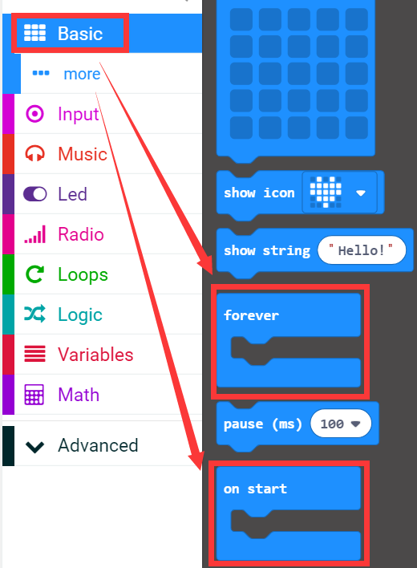

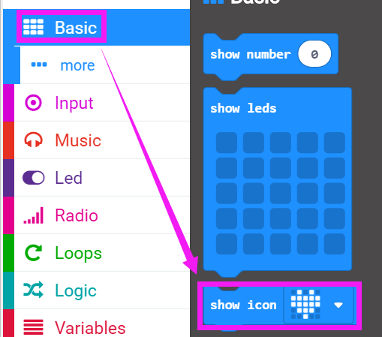

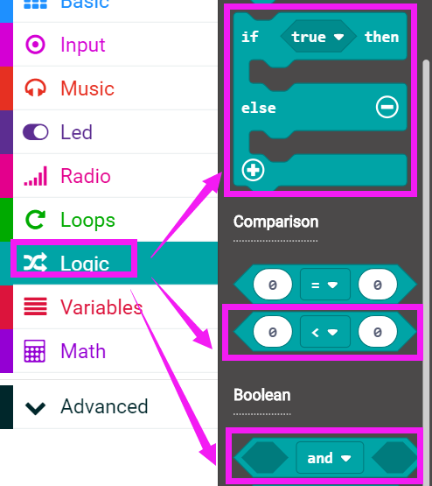

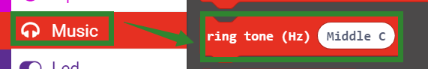

How create a new variable:

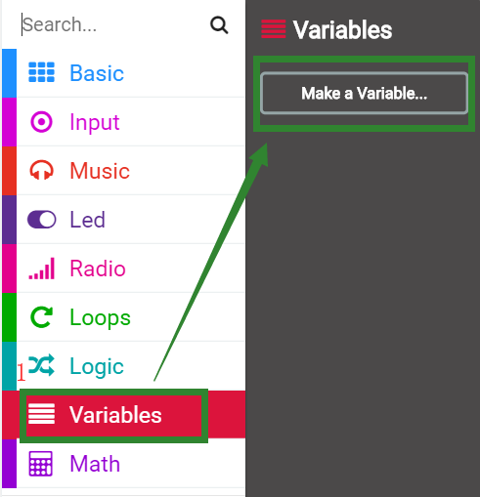

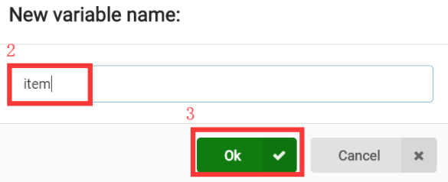

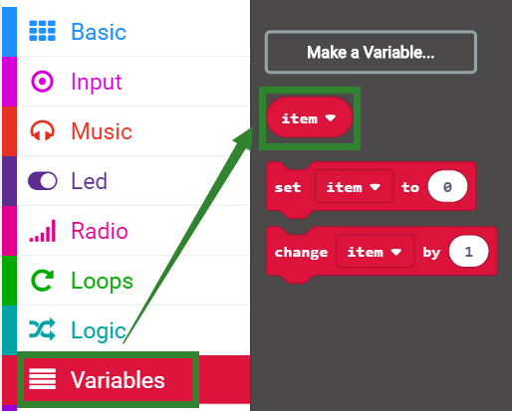

****3.Combine blocks:****

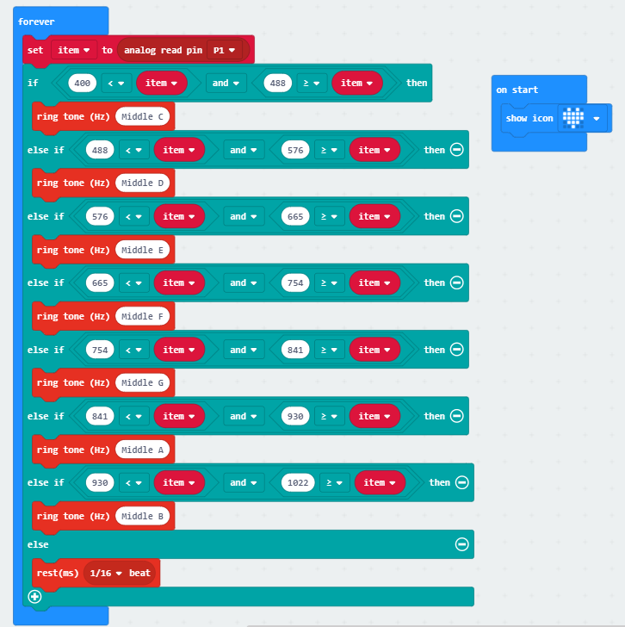

**4.Download programming**

After the program is downloaded. First, we need to use a 2B pencil to draw a thick line of about 20cm on the paper. As shown in the figure below.

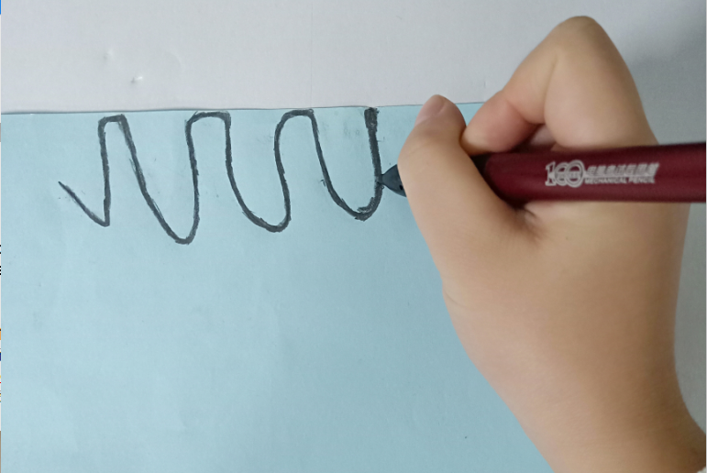

Then, we need to use one end of the alligator clip to clamp one end of the thick line on the paper, and the other end to the 3V of the micro:bit gold finger. As shown in the figure below.

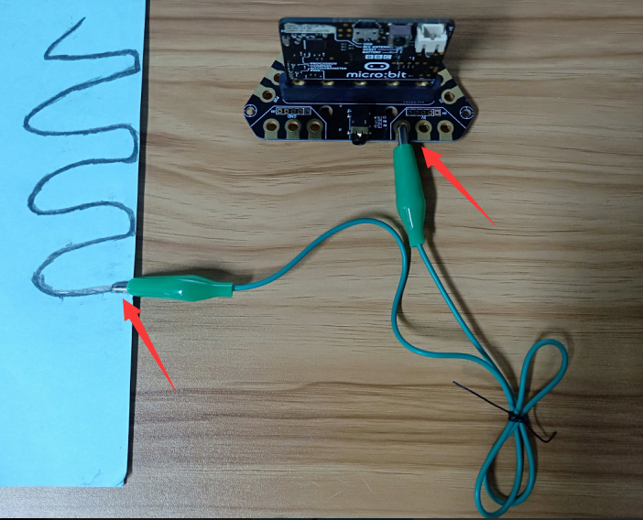

Next, we need to use one end of the alligator clip to clamp 3v on the micro:bit, and the other end to the 3V of the micro:bit gold finger. The other end click thick line on the paper by hand. As shown in the figure below.

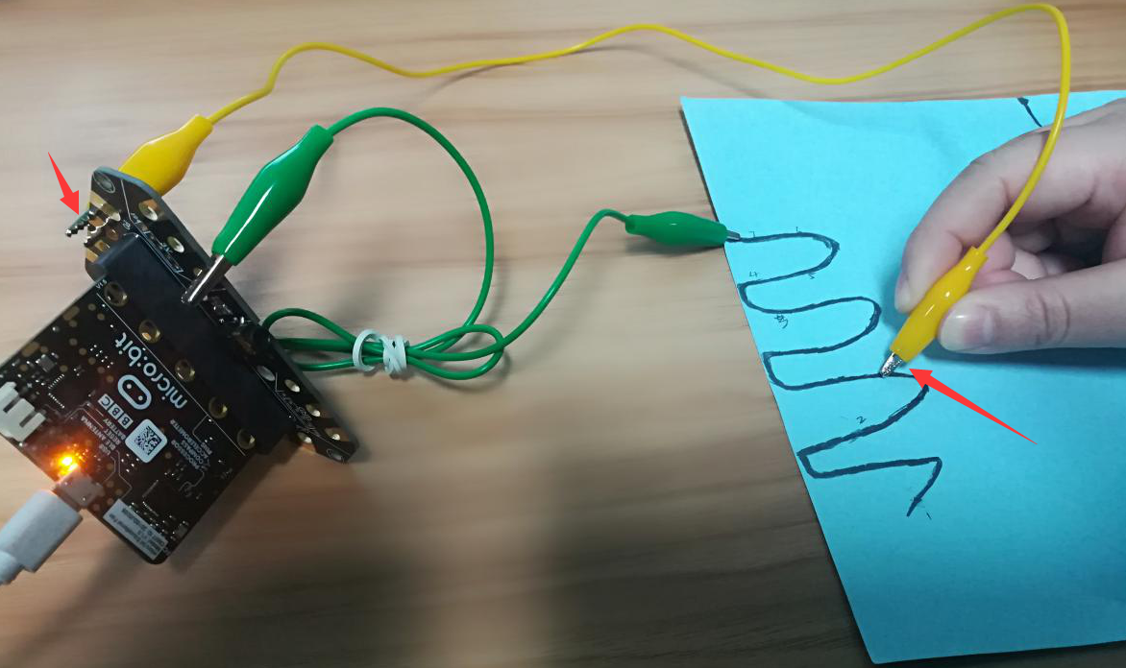

When we click different location ,we can listen that buzzer play different tones.

**Note:**

**When taking the alligator clip to touch the thick line, do not touch the metal part of the alligator clip, you should hold the insulation.**

